Chapter 1 :-

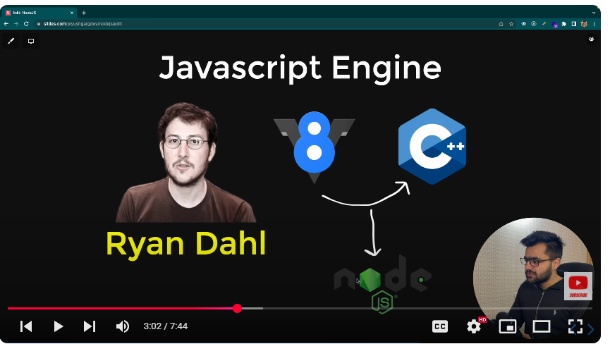

* NodeJs :- Javascript Run Time Environment , which is run out side the browser
* Nodejs is build with JavaScript V8 Engine and C++
* Nodejs Developed by Ryan Dahl

Chapter : 2

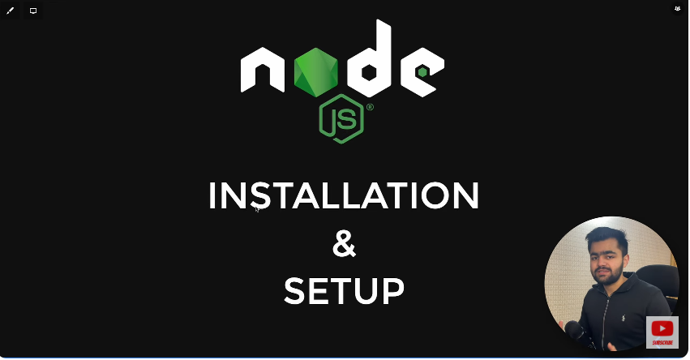

* NodeJs LTS => Long Time Support
* NodeJs Current => BETA VERSION
* Version Check => node –version
* NPM => Node Package Manager
* NPM Version => npm –v